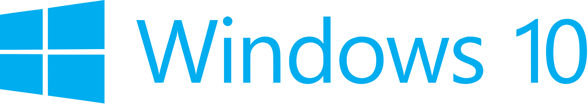

Hand­s-on lab

Lab: Launching Apps with Speech Commands

September 2015

Contents

Overview 4

Exercise 1: Launching with Voice Commands 5

Task 1 – Create a blank Universal Windows app 5

Task 2 – Create the voice commands definition file 7

Task 3 – Install the voice command definitions 9

Task 4 – Handle voice command activation 10

Exercise 2: Use a Voice Command to Change the App’s Appearance 14

Task 1 – Set the background color 14

Task 2 – Create a voice command to trigger the color change 15

Summary 17

Overview

Windows 10 apps can leverage the Cortana interface to interact with users through convenient and customizable voice commands. In addition to accessing system features, Cortana can launch your app in the foreground or interact with app data in the background.

App-specific voice commands start with a prefix, usually the app name or a keyword, to allow for infinite combinations without needing to disambiguate from other apps that may have similar commands. You can define options to speak the app name before or after the command and choose which behaviors to implement when your app is launched.

In this lab, you will create a voice command definition file and add commands to launch your app and customize its appearance.

# Objectives

* 1. This lab will show you how to:
  + Create a voice command definition file
  + Launch your app using a voice command
  + Use a switch to target incoming voice commands
  + Pass information from a voice command to the view
  + Change the app’s appearance based on an incoming voice command
  + Run a background task from a voice command
  + Return written and spoken responses to Cortana from your app

# System requirements

* 1. You must have the following to complete this lab:
  + Microsoft Windows 10
  + Microsoft Visual Studio 2015

# Setup

* 1. You must perform the following steps to prepare your computer for this lab:
  2. Install Microsoft Windows 10.
  3. Install Microsoft Visual Studio 2015.

# Exercises

* 1. This Hands-on lab includes the following exercises:
  2. Launching with Voice Commands
  3. Use a Voice Command to Change the App’s Appearance
  4. Estimated time to complete this lab:  **30 to 45 minutes**.

Exercise 1: Launching with Voice Commands

1. Voice commands provide a convenient, hands-free alternative for launching your app. To implement voice commands, you will create a simple schema with a command to launch your app and the corresponding response from Cortana. You will register the commands with Cortana and use the OnActivated start case to initiate the activation of your app in the foreground.

Task 1 – Create a blank Universal Windows app

We will begin by creating a project from the Blank App template.

1. In a new instance of Visual Studio 2015, choose **File > New> Project** to open the New Project dialog. Navigate to **Installed > Templates > Visual C# > Windows > Universal** and select the **Blank App (Universal Windows)** template.
2. Name your project **SpeechRecognition** and select the file system location where you will save your Hands-on Lab solutions. We have created a folder in our **C:** directory called **HOL** that you will see referenced in screenshots throughout the labs.

Leave the options selected to **Create new solution** and **Create directory for solution**. You may deselect both **Add to source control** and **Show telemetry in the Windows Dev Center** if you don't wish to version your work or use Application Insights. Click **OK** to create the project.

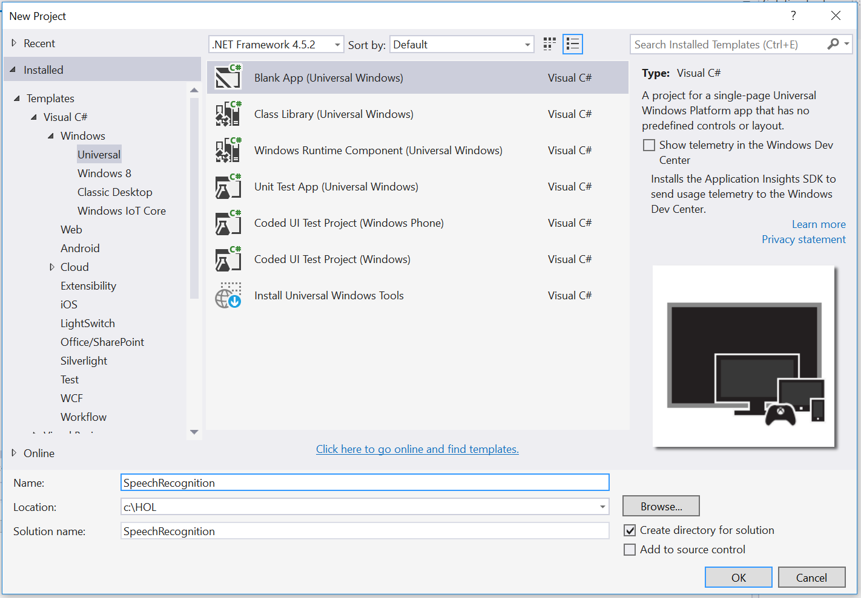

Figure 1

Create a new Blank App project in Visual Studio 2015.

1. Set your Solution Configuration to **Debug** and your Solution Platform to **x86**. Select **Local Machine** from the Debug Target dropdown menu.

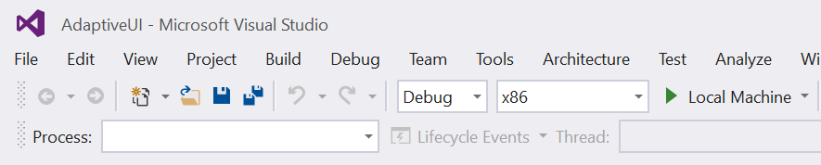

Figure 2

* + 1. Configure your app to run on the Local Machine.

1. Build and run your app. You will see a blank app window with the frame rate counter enabled by default for debugging.

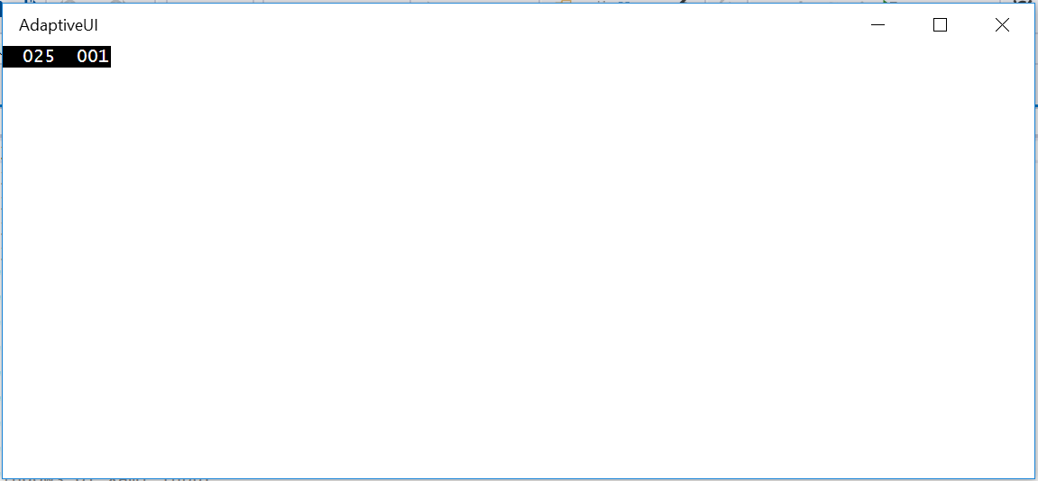

Figure 3

The blank universal app running in Desktop mode.

* 1. **Note:** The frame rate counter is a debug tool that helps to monitor the performance of your app. It is useful for apps that require intensive graphics processing but unnecessary for the simple apps you will be creating in the Hands-on Labs.
  2. In the Blank App template, the preprocessor directive to enable or disable the frame rate counter is in **App.xaml.cs**. The frame rate counter may overlap or hide your app content if you leave it on. For the purposes of the Hands-on Labs, you may turn it off by setting **this.DebugSettings.EnableFrameRateCounter** to **false**.

1. Return to Visual Studio and stop debugging.

Task 2 – Create the voice commands definition file

The voice command schema is defined in an XML file. In this task, you will create a simple schema with a command to handle launching the app.

1. Right-click on your project name and choose **Add > New Item**.
2. Select the XML file type and give it the name **VoiceCommands.xml**.

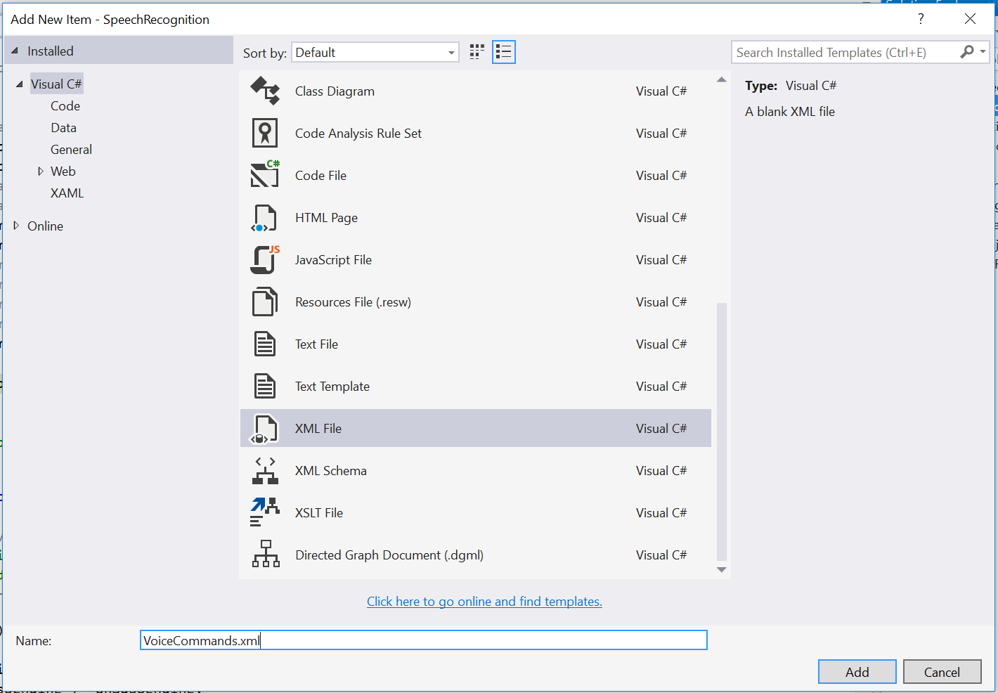

Figure 4

Create the voice commands xml file.

1. Open VoiceCommands.xml reference the xml version and the VoiceCommands schema. Add the command set.
   * 1. XML
   1. <?xml version="1.0" encoding="utf-8" ?>
   2. <VoiceCommands xmlns="http://schemas.microsoft.com/voicecommands/1.2">
   3. <CommandSet xml:lang="en-us" Name="HoLCommandSet_en-us">
   4. </CommandSet>
   5. </VoiceCommands>
2. Add a command preset to your definition. The command preset is the word or phrase your users can speak to tell the system to start listening for commands from your app.
   * 1. XML
   1. <?xml version="1.0" encoding="utf-8" ?>
   2. <VoiceCommands xmlns="http://schemas.microsoft.com/voicecommands/1.2">
   3. <CommandSet xml:lang="en-us" Name="HoLCommandSet_en-us">
   4. <CommandPrefix> Hands on Labs, </CommandPrefix>
   6. </CommandSet>
   7. </VoiceCommands>
3. Our goal is to launch the app from a voice command. Create a launch command with a **Navigate** element. Add an **Example** element to the **CommandSet**.
   * 1. XML
   1. <?xml version="1.0" encoding="utf-8" ?>
   2. <VoiceCommands xmlns="http://schemas.microsoft.com/voicecommands/1.2">
   3. <CommandSet xml:lang="en-us" Name="HoLCommandSet_en-us">
   4. <CommandPrefix> Hands on Labs, </CommandPrefix>
   5. <Example> Launch </Example>
   6. <Command Name="LaunchApp">
   7. <Example>launch</Example>
   8. <ListenFor>launch</ListenFor>
   9. <Feedback>Opening your speech recognition app</Feedback>
   10. <Navigate />
   11. </Command>
   12. </CommandSet>
   13. </VoiceCommands>
   14. **Note:** The Navigate element signifies that the app will launch in the foreground. The alternative to launching in the foreground is to define a WinRT component to handle behind-the-scenes interactions with app data through Cortana. You can learn more about Voice Command Definitions at <https://msdn.microsoft.com/en-us/library/windows/apps/dn722331.aspx>

Task 3 – Install the voice command definitions

We will install the voice command definitions (VCD) in the **OnLaunched** override. There is no simple way to test if the VCD has been imported, or if it is the most recent version, so it is convenient to install it when the app is launched for the first time.

1. Open **App.xaml.cs** and add the following lines to the **OnLaunched** override:
   * 1. C#
   1. protected override async void OnLaunched(LaunchActivatedEventArgs e)
   2. {
   3. //#if DEBUG
   4. // if (System.Diagnostics.Debugger.IsAttached)
   5. // {
   6. // this.DebugSettings.EnableFrameRateCounter = true;
   7. // }
   8. //#endif
   9. var storageFile = await Windows.Storage.StorageFile.GetFileFromApplicationUriAsync(new Uri("ms-appx:///VoiceCommands.xml"));
   10. await Windows.ApplicationModel.VoiceCommands.VoiceCommandDefinitionManager.InstallCommandDefinitionsFromStorageFileAsync(storageFile);
   11. Frame rootFrame = Window.Current.Content as Frame;
   12. **Note:** The voice command definition (VCD) will be installed the first time the app is launched with a start kind of **Launched**. You can open your app from the Start menu to ensure the voice commands are registered.

Task 4 – Handle voice command activation

When your app is launched via voice command, it has a start kind of **Activated**. Accordingly, we will handle incoming voice commands in the **OnActivated** override. In this task, you will create a switch to evaluate the **LaunchApp** command and navigate to the MainPage view if the command has been used to start the app.

1. Create an **OnActivated** override in **App.xaml.cs**. A voice command launch has a start kind of **OnActivated**, so you will handle the incoming voice command here.
   * 1. C#
   1. protected override void OnActivated(IActivatedEventArgs args)

{

* 1. base.OnActivated(args);
  2. }

1. Add a switch to handle the **ActivationKind.VoiceCommand** case and call a method named **HandleVoiceCommand**. You will create the **HandleVoiceCommand()** method in the next step.
   * 1. C#
   1. protected override void OnActivated(IActivatedEventArgs args)
   2. {
   3. switch (args.Kind)
   4. {
   5. case ActivationKind.VoiceCommand:
   6. HandleVoiceCommand(args);
   7. break;
   9. default:
   10. break;
   11. }
   12. base.OnActivated(args);
   13. }
2. Create the **HandleVoiceCommand()** method. This method determines the incoming voice command and implements a switch based on the voice command name. You defined the **LaunchApp** command in your voice command definitions file in Task 2.
   * 1. C#
   1. private void HandleVoiceCommand(IActivatedEventArgs args)

{

* 1. var commandArgs = args as VoiceCommandActivatedEventArgs;
  2. var speechRecognitionResult = commandArgs.Result;
  3. var command = speechRecognitionResult.Text;
  4. var voiceCommandName = speechRecognitionResult.RulePath[0];
  5. var textSpoken = speechRecognitionResult.Text;
  6. switch (voiceCommandName)
  7. {
  8. case "LaunchApp":
  9. break;
  10. default:
  11. break;
  12. }
  13. }

1. To successfully launch the app and navigate to a page, we will need to recreate some of the behavior that currently lives in the OnLaunched override. The Blank App template creates the root frame and activates the window when the app is launched, but does not provide this behavior for OnActivated cases. Add the code to handle these start up tasks.
   * 1. C#
   1. protected override void OnActivated(IActivatedEventArgs args)
   2. {
   3. Frame rootFrame = Window.Current.Content as Frame;
   4. if (rootFrame == null)
   5. {
   6. // Create a Frame to act as the navigation context and navigate to the first page
   7. rootFrame = new Frame();
   8. rootFrame.NavigationFailed += OnNavigationFailed;
   9. // Place the frame in the current Window
   10. Window.Current.Content = rootFrame;
   11. }
   12. switch (args.Kind)
   13. {
   14. case ActivationKind.VoiceCommand:
   15. HandleVoiceCommand(args);
   16. break;
   18. default:
   19. break;
   20. }
   21. Window.Current.Activate();
   22. base.OnActivated(args);
   23. }
   24. **Note:** To avoid duplication in a real-world app, you may want to create common startup code that will run for both launched and activated apps. Template10 demonstrates a more unified way of handling these essential steps on app startup. For more on Template10, visit <https://github.com/Windows-XAML/Template10>
2. Pass the root frame into the **HandleVoiceCommand** method in addition to **args**. You will need the context of the rootFrame to navigate to a page.
   * 1. C#
   1. switch (args.Kind)
   2. {
   3. case ActivationKind.VoiceCommand:
   4. HandleVoiceCommand(args, rootFrame);
   5. break;
   7. default:
   8. break;
   9. }
3. In the **HandleVoiceCommand** method, add the incoming **frame** parameter and use it to navigate to the **MainPage** view when the **LaunchApp** command is detected.
   * 1. C#
   1. private void HandleVoiceCommand(IActivatedEventArgs args, Frame frame)

{

* 1. var commandArgs = args as VoiceCommandActivatedEventArgs;
  2. var speechRecognitionResult = commandArgs.Result;
  3. var command = speechRecognitionResult.Text;
  4. var voiceCommandName = speechRecognitionResult.RulePath[0];
  5. var textSpoken = speechRecognitionResult.Text;
  6. switch (voiceCommandName)
  7. {
  8. case "LaunchApp":
  9. frame.Navigate(typeof(MainPage));
  10. break;
  11. default:
  12. break;
  13. }
  14. }

1. Open MainPage.xaml and add a page title. The text will help to determine that navigation has taken place when your app is launched.
   * 1. XAML
   1. <Grid Background="{ThemeResource ApplicationPageBackgroundThemeBrush}">
   2. <TextBlock Text="Speech Recognition and Voice Commands" FontWeight="Light" FontSize="20" Margin="12" />
   3. </Grid>
2. Right-click on your project in the Solution Explorer and choose **Deploy**. Launch your app from the Start menu to ensure the **OnLaunched** override registers the VCD.

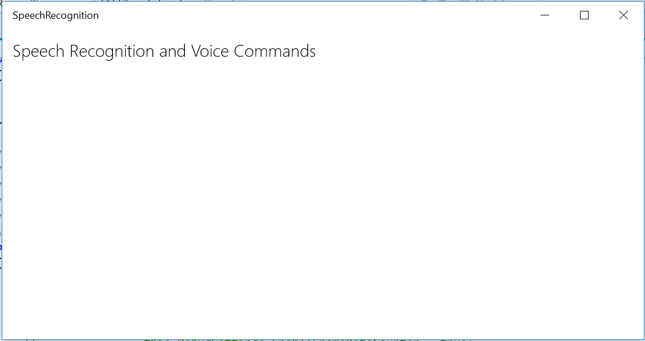

Figure 5

The app launched from the Start menu.

1. Close your app. Click the microphone button in your task bar to prepare to launch via voice command.
2. Say the words “Hands-on Labs, launch.” Cortana will verbally confirm that she is opening your Speech Recognition app. Your app will launch and navigate to the MainPage view.



Figure 6

The app launches via voice command.

1. Close your app and return to Visual Studio.

Exercise 2: Use a Voice Command to Change the App’s Appearance

* 1. In addition to launching your app, voice commands can interact with content in the app. In this exercise, you will use a voice command to change the background color of your app when it launches.

Task 1 – Set the background color

* 1. In this task, you will set an initial background color for your app and specify an **x:Name** attribute to make it easier to target the grid’s properties.

1. Specify **AliceBlue** as the background color for your grid in **MainPage.xaml**.
   * 1. XAML
   1. <Grid Background="AliceBlue">
   2. <TextBlock Text="Speech Recognition and Voice Commands" FontWeight="Light" FontSize="20" Margin="12" />
   3. </Grid>
2. Give the grid the x:Name **Container**.
   * 1. XAML
   1. <Grid Background="AliceBlue">
   2. <TextBlock Text="Speech Recognition and Voice Commands" FontWeight="Light" FontSize="20" Margin="12" />

</Grid>

1. Build and run your app on the Local Machine. You will see the page title on a light blue background.

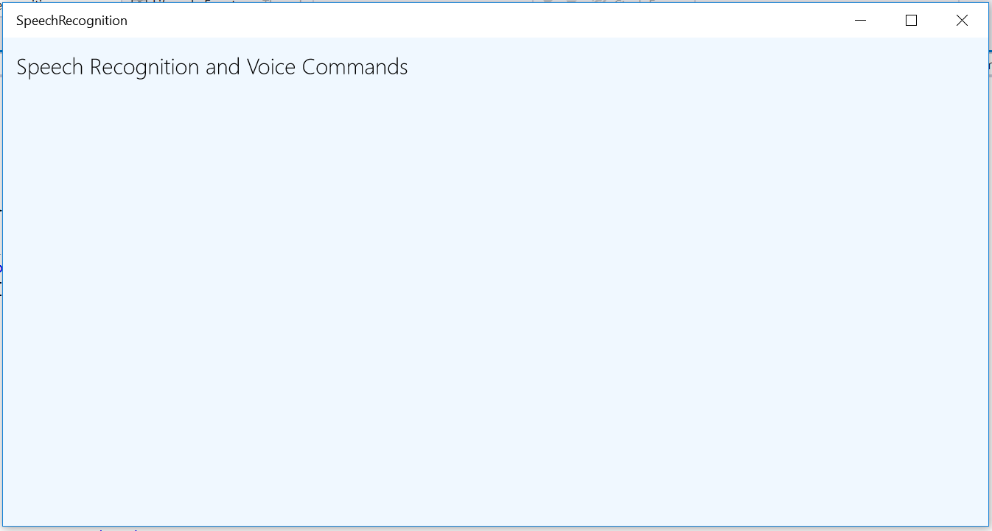

Figure 7

The app launches via voice command.

1. Stop debugging and return to Visual Studio.

Task 2 – Create a voice command to trigger the color change

* 1. In this task, you will create a voice command to change the background color of the grid to red.

1. Open your VoiceCommands.xml definition file and add a new command. Give the command the name **TurnRed.**
   * 1. XML
   1. <Command Name="TurnRed">
   2. <Example>turn red</Example>
   3. <ListenFor>turn red</ListenFor>
   4. <Feedback>My favorite color is red</Feedback>
   5. <Navigate />
   6. </Command>
2. Add a case for the **TurnRed** command to the **voiceCommandName** switch in **App.xaml.cs**. This time, pass a parameter to MainPage when navigating.
   * 1. C#
   1. switch (voiceCommandName)
   2. {
   3. case "LaunchApp":
   4. frame.Navigate(typeof(MainPage));
   5. break;
   6. case "TurnRed":
   7. frame.Navigate(typeof(MainPage), "Red");
   8. break;
   9. default:
   10. break;
   11. }
3. Open the MainPage code behind and create an **OnNavigatedTo** override to handle the incoming parameter. Set the grid background to a color that corresponds to the incoming parameter.
   * 1. C#
   1. protected override void OnNavigatedTo(NavigationEventArgs e)
   2. {
   3. if (e.Parameter.ToString() == "Red")
   4. Container.Background = new SolidColorBrush(Colors.DarkRed);
   5. base.OnNavigatedTo(e);
   6. }
4. Right-click on your project in the Solution Explorer and choose **Deploy**.
5. Launch your app from the Start menu to register the new voice command. You should still see the blue background. Close your app.
6. Launch your app with the voice command **“Hand-on Labs, turn red.”** Cortana will respond that red is her favorite color. When the app launches, you will see the background is now red.

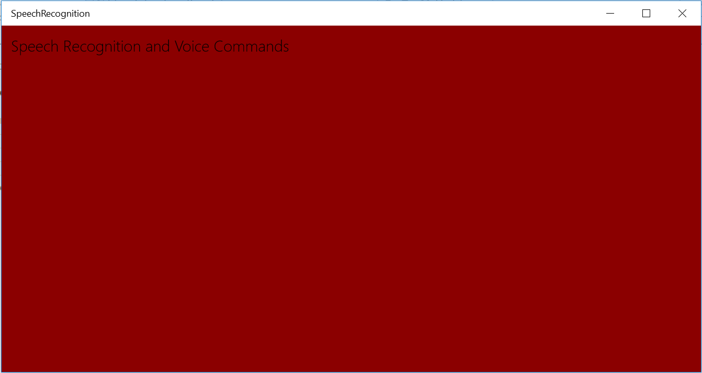

Figure 8

The app launches via voice command with a red background.

1. Stop debugging and return to Visual Studio.

Summary

* 1. Voice commands handle important interactions in Windows 10. In this lab, you created a voice command definition file and explored the VCD schema. You also added commands to launch the app, and interact with its appearance.